 | The CAMECA IMS 7f (*) Software user’s guide  Tools  00 45 610 683 - Type 108 – Indice B
0000.doc
(*) This documentation is relevant for the IMS7f the number of which is equal or larger than 715

Aug07: Update of the Spotshape tool
Aug 08: Update of FCp offset in the sampling mode
Index

Contents

1. Overview 3
1.1 The TOOLS Software 3
1.2 The Set-Up files 3
1.3 The Oscilloscope 4
2. The Oscilloscope and stability 4
2.1 The Oscilloscope box 4
2.2 The Statistics processing 6
3. Fcp Measurement and FCp offset 6
3.1 Overview 6
3.2 Description 7
3.2.1 The Fcp Measurement box 7
3.2.2 The FCp measurement parameters box 8
3.3 FCp offset routine 9
3.4 FCp measurement links with the Setup file 10
4. FCs Measurement and FCs offset 10
4.1 Overview 10
4.2 Description 11
4.2.1 The Fcs Measurement box 11
4.2.2 The FCs measurement parameters box 12
4.3 FCs offset routine 12
4.4 FCs links with the Setup file 14
5. EM Measurement 15
5.1 Overview 15
5.2 Description 15
5.2.1 The EM Measurement Box 15
5.2.2 The EM measurement parameters box 16
5.3 Links with the Setup file 17
6. The EM Yield test 17
6.1 Overview 17
6.2 Description 18
6.2.1 The EM Yield main box 18
6.2.2 The EM Yield parameter box 19
6.3 Links with the Setup file 19
7. The EM PHA 19
7.1 Overview 19
7.2 Description 20
7.2.1 The EM PHA main box 20
7.2.2 The EM PHA Measurement Parameters Box 21
7.2.3 The EM PHA Curve Box 21
7.3 Links with the Setup file 22
8. The EM HV routine 22
8.1 Overview 22
8.2 Description 23
8.3 EM HV links with the Setup file 24
9. Diagnosis 25
10. Spot Shape 25
10.1 Overview 25
10.2 Procedure to measure a beam size with the single mode 28
10.3 Procedure to measure a beam size with the double mode 29
10.4 the result box 33
10.5 Other boxes 33
10.6 Spot Shape links with the Setup file 34
11. Analysis Filter 34
11.1 Overview 34
11.2 Opening the tool and saving the output file 35
11.3 Description 36
11.4 The filter process 39
11.4.1 Overview 39
11.4.2 Computing the output "Measurement" 39
11.4.2.1 Overview 39
11.4.2.2 The EM case (1 point per cycle) 39
11.4.2.3 The FCs Case (1 point per cycle) 40
11.4.2.4 The mixed EM and FCs case (1 point per cycle) 41
11.4.2.5 The "1 point per N frames" Mode 41
11.4.3 Computing the output "Sputtering time" 42
11.4.4 Computing the output "FCp" 42
11.4.5 Other output data 43
11.5 Setup file parameters 43
12. The additional analysis parameters: magnet settling time, FC/EM threshold 44
13. The set-up browser 45

Contents ↑

Overview

The TOOLS Software

Main Tool barl
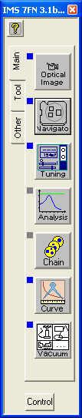 | 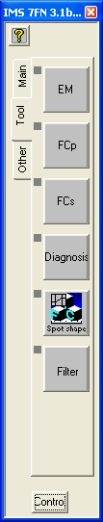 | TOOLS is a set of software which allows to control a specific part of the instrument.  TOOLS can be called from the main Bar Menu (Tool tab).  Click the main bar TOOLS tab  EM button offers 4 possible tools:  - EM Measurement  - EM HV  - EM Yield  - EM PHA  FCp button offers 2 possible tools:  - FCp measurement  - FCp offset  FCs button offers 2 possible tools:  - FCs measurement  - FCs offset

Each specific Tool allows to run test and/or to edit parameters used in other applications such as analyses. All the perameters which can be edited in TOOLS can also be edited in SET-UP.
Contents ↑

The Set-Up files
Several hundred of instrument parameters are stored in the set-up file. It is possible to display, edit and search these parameters by the mean of a special browser (see below the section § The Set-up browser). Some parameters, especially the more used, can be edited by a dedicated tool, additionally to the set-up browser. For instance, the EM Yield can be edited with the set-up browser (#255), but also with the EM Measurement tool. Moreover, it can be automatically set by the routine Yield, available from the Tool pad menu. At the opposite, the parameter EM_YIELD_MIN, which is the minimum EM Yield value allowed by the program can be edited only with the set-up browser.
Contents ↑

The Oscilloscope
The Oscilloscope is a facility which can be called by the different tools involving acquisitions (Fcp, Fcs, EM, Multichannel, Crater depth). It is purposed to display measured signals as a XY plot, with the time in abcissa. The Oscilloscope can also perform some elementary statistics computation over the acquired data.

The Oscilloscope and stability

The Oscilloscope box
The tool from which the ocilloscope is called determines the signal displayed in Y in the graphic window. In any case, the signal is plotted versus the time. For instance, if the oscilloscope is called from EM Measurement, the EM signal will be plotted versus the time.
The storage of the acquired data in the graphic window is started by Record START . A maximum of 5600 points can be stored.
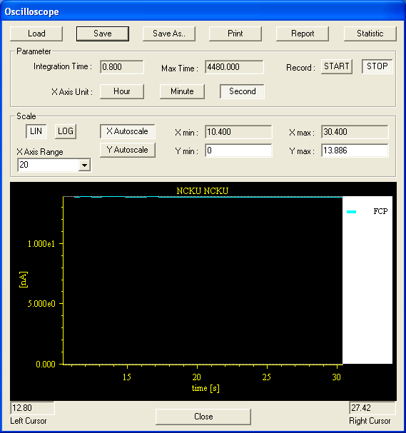
- Load opens a browser which allows to load a file previously saved. Load is purposed to re-process the data with the stability facility.
- Save saves the oscilloscope data in the current oscilloscope file. This current file name is determined by the last Save as. The oscilloscope file can be edited either by an ASCII editor or by a spreadsheet.
- Save as opens a browser which allows to edit a filename for saving the oscilloscope data.
- Print transfers the graphic window towards the printer.
- Report transfers the Statistics processing results in a word formatted document.
- Statistics allows to compute features of the part of the curve comprised between both cursors. These cursors can be defined by clicking successively the mouse right button and the mouse left button. (See below The Statisticsy processing)
- Integration time displays the integration time edited in the tool which called Oscilloscope. (See, for example Fcp Measurement)
- Record START/STOP starts and stops the data storage.
- X axis unit (hours/min/sec) selects the X axis time unit.
- Lin/Log selects the Y axis scale mode.
- X Autoscale If X Autoscale is ON (pushed), the abcissa time range is selected by the button localed at the Scale box bottom left. If X Autoscale is OFF (not pushed), the abcissa time range is determined by the edited limits Xmin and Xmax.
- Y autoscale If Y Autoscale is ON (pushed), the ordinate time range is determined by the signal minimum and maximum over the X range. If Y Autoscale is OFF (not pushed), the ordinate time range is determined by the edited limits Ymin and Ymax.
- Close closes the box without saving the data in the current file.

The Statistics processing
After having clicked statistics, it is necessary to define the statistics interval boundaries by clicking (left and right mouse buttons) the graphic window. 2 vertical cursors are then displayed at the clicked locations. The statistical data will be computed over the statistics interval.

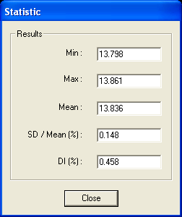 | - Min is the minimum signal amplitude over the stability interval.  - Max is the maximum signal amplitude over the stability interval.  - Mean is the averaged signal amplitude over the stability interval.  - SD/Mean (%) is the signal standard deviation expressed in percentage with respect to the Mean.  - Di (%) = 100 x (Max-Min)/Mean

Contents ↑

Fcp Measurement and FCp offset

Overview
This tool is targetted to the measurement of the primary ion current. The primary current is measured with a Faraday cup device, Fcp, quite similar to the secondary Faraday cup, Fcs, described in the ion optics user's guide. A pair of Beam_Blanking plates (BBP) allow to deflect the primary beam into the Fcp Faraday cup. The BBP deflection amplitude is tuned for each ISF (See the Tuning software user's guide)
The primary ion beam current can be measured either with the Static Mode or with the Sampled Mode. As it is explained in the ion optics user's guide, the Sampled Mode allows to monitor the primary beam while keeping it working, by sampling the beam along the time towards a Faraday Cup.
With the Static Mode, the beam is more conventionally deflected permanently into the Faraday cup.

Description

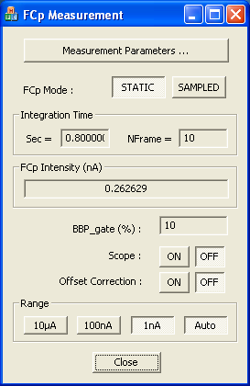 | 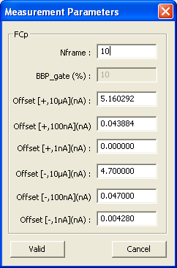

The Fcp Measurement box

- Measurement parameters : clicking this button opens the editing box Measurement Parameters. The box is opened with the parameter values as they are in the setup file.
- Fcp Mode (Static/Sampled): ): Clicking one button switches the measurement mode - See above for the definition of both modes, Static/Sampled – (Setup #315) Static is actually equivalent to Beam off.
- Integration time. Is displayed both in second (Sec=) or in number of 80 ms frames (Ntrame=) . Both are dependent, according to the relationship
- sec = Nframe * 80 ms
The measured current will be averaged among the Nframe frames and displayed in the Fcp Intensity field. Nframe is edited in the Measurement parameter box.
- Fcp Intensity (nA) displays the primary current, averaged over Nframe frames.
- BBP-gate displays the sampling rate, as it is defined in the ion optics user's guide , i.e. the time percentage during which the beam is deflected into the Fcp Faraday cup. BBP_gate is actually edited in the Measurement parameters box.
- Scope ON/OFF, switching button for opening and closing the Oscilloscope box.
- Offset correction (ON/OFF), switching button for enabling/disabling the offset correction defined by the offset parameters edited in the Measurement parameters box. (Setup#496)
- Range (10µA/100nA/1nA/Auto). Swiches the Fcp preamplifier range. Each range corresponds to a different resistor. When Auto is selected, the range is automatically selected, according to the actual measured value, and its correspunding button is displayed as pushed. The same selection concerns also the real time screen display. (Setup #318 for 10µA/100nA/1nA and Setup#497 for Auto ON/OFF)
Contents ↑

The FCp measurement parameters box
- Nframe edits the number of 80 ms frames which define the acquisition integration time - (Setup #24)
- BBP_gate (%)edits the Fcp measurement sampling rate. (related to Setup#321)
- Offset [+, 10µA] (nA) edits the offset corresponding to a positive primary polarity and to the range 10 µA. See below the way to determine it. (Setup#324)
- Offset [+, 100nA] (nA) edits the offset corresponding to a positive primary polarity and to the range 100nA. See below the way to determine it. (Setup#327)
- Offset [+, 1nA] (nA) edits the offset corresponding to a positive primary polarity and to the range 1nA. See below the way to determine it. (Setup#330)
- Offset [-, 10µA] (nA) edits the offset corresponding to a negative primary polarity and to the range 10 µA. See below the way to determine it. (Setup#333)
- Offset [-, 100nA] (nA) edits the offset corresponding to a negative primary polarity and to the range 10 µA. See below the way to determine it. (Setup#336)
- Offset [-, 1nA] (nA) edits the offset corresponding to a negative primary polarity and to the range 1nA. See below the way to determine it. (Setup#339)
- Apply writes in the Setup file the Measurement Parameters box modified parameters and closes the box
- Cancel closes the box without writing in the setup file the box modified values.

How to determine the FCp offset ?
  - Use the FCp offset routine (see below the section § The FCp offset routine)

Contents ↑

FCp offset routine
Available from the main Tools bar, FCp button + FCp offset.
The FCp offset routine allows to record automatically the different FCp offset values corresponding to the different ranges without typing them.

It is recommended to run this routine without any current in the primary column (Source OFF or valve closed)

For measuring the FCp offset, the primary ion current is set out of the Faraday cup (Beam ON), and after a "1st waiting time" the Faraday current is read during an "Offset time". The beam is thereafter switched OFF and ON for a purpose not implemented on the IMS 7f .
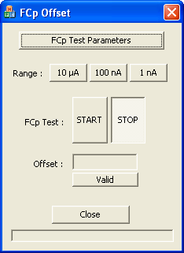 | 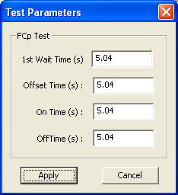

FCp Test main box:
- FCp test Parameters : clicking this button opens the editing box FCp Test Parameters. The box is opened with the parameter values as they are in the setup file.
- Range (10µA/100nA/1nA) selects the FCp range.
- FCp Test (Start/Stop) launches the routine the parameters of which are edited in the FCp Test parameters box
- Offset displays the value resulting from the FCp routine.
- Valid writes the above displayed value in the setup file.
- Close closes the box.
FCp Test parameters
- 1st Wait Time (s) is the delay between the BEAM ON command which drives the primary current out of the Faraday cup and the beginning of the FCp measurement. (typ. 4 sec) (Setup # 342)
- Offset Time (s) determines the number of frames averaged for the FCp offset measurement. (typ. 4 sec) (Setup # 345)
- ON Time (s) Beam OFF time. (typ 0.) (Setup # 348)
- OFF Time (s) Beam ON time. (typ 0.) (Setup # 351)
- Apply writes in the Setup file the FCp Test Parameters box modified parameters and closes the box
- Cancel closes the box without writing in the setup file the box modified values.

FCp measurement links with the Setup file
FCp measurement parameters
# | Set-up Label | Comments
24 | Integrat time for the Prim Cur | (FCp Measurement tool)
315 | FCP_MODE_VAL | Fcp Mode (Static/Sampled)
318 | FCP_RANGE_VAL | Fcp measurement range (10µA/100nA/1nA)
321 | FCP_NLINE_BBP_ON_VAL | Depends on the sampling rate as  511(1-100*(BBP_gate%))
324 | FCP_OFFSET_R1_POS_VAL | Positive Primary Range=10µA Faraday offset
327 | FCP_OFFSET_R2_POS_VAL | Positive Primary Range=100nA Faraday offset
330 | FCP_OFFSET_R3_POS_VAL | Positive Primary Range=1nA Faraday offset
333 | FCP_OFFSET_R1_NEG_VAL | Negative Primary Range=10µA Faraday offset
336 | FCP_OFFSET_R2_NEG_VAL | Negative Primary Range=100nA Faraday offset
339 | FCP_OFFSET_R3_NEG_VAL | Negative Primary Range=1nA Faraday offset
496 | Primary Faraday Cup offset correction | (0/1)
497 | Primary Faraday Autorange flag | (0/1)

Additionnal FCp test parameters
# | Set-up Label | Comments
342 | FCP_TEST_WAIT_TIME_VAL | (FCp Offset Test Tool)
345 | FCP_TEST_OFFSET_TIME_VAL | (FCp Offset Test Tool)
348 | FCP_TEST_BBP_ON_TIME_VAL | (FCp Offset Test Tool)
351 | FCP_TEST_BBP_OFF_TIME_VAL | (FCp Offset Test Tool)

FCp offset in the Sampling mode.
Primary FCp offsets in the sampling mode may be different from the static mode. Refer to Tuning/Setup box

Contents ↑

FCs Measurement and FCs offset

Overview
This tool is targetted to the measurement of the secondary ion current with the Faraday Cup (FCs). For the description of the Faraday Cup device, see the ion optics user's guide.
For obtaining a FCs signal, it is necessary to switch the beam towards the FCs device, by clicling FC on the Tuning main bar.

Description

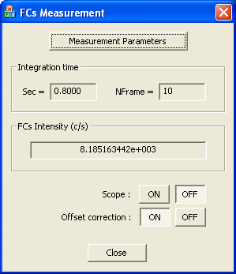 | 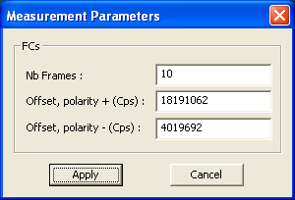

The Fcs Measurement box

- Measurement parameters : clicking this button opens the editing box Measurement Parameters. The box is opened with the parameter values as they are in the setup file.
- Integration time. Is displayed both in second (Sec=) or in number of 80 ms frames (Ntrame=) . Both are dependent, according to the relationship
sec = Nframe * 80 ms
The FCs signal is averaged over the Nframe frames and displayed in the FCs Intensity field. Nframe is edited in the FCs Measurement parameter box.
- FCs Intensity (c/s) displays the FCs measured signal, expressed in counts per second, averaged over Nframe frames.
- Scope ON/OFF, switching button for opening and closing the Oscilloscope box.
- Offset correction (ON/OFF), switching button for enabling/disabling the FCs offset correction. The same selection is valid for Tuning (Real Time screen) and for the analyses (exept for image analysis) but not for Mass Calibration. The FCs offset can be edited in the FCs Measurement parameter box. (Setup #517)

Contents ↑

The FCs measurement parameters box
- Nframe edits the number of 80 ms frames which define the acquisition integration time - (Setup #44)
- FCs Offset + (Cps) edits the offset corresponding to a positive secondary polarity. See below the way to determine it. (Setup#387)
- FCs Offset - (Cps) edits the offset corresponding to a negative secondary polarity. See below the way to determine it. (Setup#607)
- Apply writes in the Setup file the Measurement Parameters box modified parameters and closes the box
- Cancel closes the box without writing in the setup file the box modified values.

How to determine the FCs offset ?
  - Use the FCs offset routine (see below the section § The FCs offset routine)
Contents ↑

FCs offset routine
Available from the main Tools bar, FCs button + FCs offset.
The FCs offset routine allows to record automatically FCs offset value corresponding to the current secondary polarity without typing it.
For measuring the FCs offset, the primary ion current is set out of the Faraday cup (BBS ON), and after a "1st waiting time" the Faraday current is read during an "Offset time". The BBS beam-blanking is thereafter switched OFF and ON for a purpose not implemented on the IMS 7f.

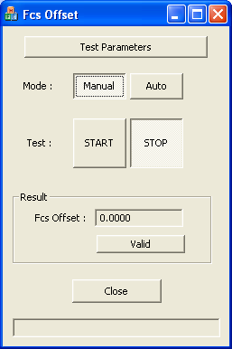 | 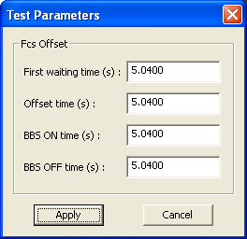

FCs Test main box:
- FCs Test parameters : clicking this button opens the editing box FCs Test Parameters. The box is opened with the parameter values as they are in the setup file.
- Mode (Manual/Auto) With Auto the routine will be launched with START, and the result will be automatically wrote in the setup file. With Manual, the routine will be also launched with START, but the operator will be asked to validate the result for writing it in the setup file.
- FCs Test (Start/Stop) launches the routine the parameters of which are edited in the FCs Test parameters box
- Offset displays the value resulting from the FCs routine.
- Valid writes the above displayed value in the setup file if the Manual mode was selected. If Auto was selected, the resulting offset value is automatically written.
- Close closes the box.
FCs Test parameters
- 1st Wait Time (s) is the delay between the BBS ON command which drives the secondary current out of the Faraday cup and the beginning of the FCp measurement. (typ. 4 sec) (Setup # 390)
- Offset Time (s) determines the number of frames averaged for the FCs offset measurement. (typ. 4 sec) (Setup # 393)
- ON Time (s) BBS OFF time. (typ 0.) (Setup # 396)
- OFF Time (s) BBS ON time. (typ 0.) (Setup # 399)
- Apply writes in the Setup file the FCs Test Parameters box modified parameters and closes the box
- Cancel closes the box without writing in the setup file the box modified values.

FCs links with the Setup file

FCs Measurement parameters
# | Set-up Label | Comments
44 | Integrat time for the Sec current | (FCs Measurement tool)
387 | FCs Offset (pos. polarity) value | (FCs Measurement tool, FCs Test tool, Tuning, Analyses)
501 | Optical gate flag | (0/1) (EM & FCs Measurement tool)
513 | E-Gate norm. flag | (0/1) (EM & FCs Measurement tool, EM PHA tool)
515 | BBS flag | (0/1) must be always to 0 except in EM & FCs Measurement tool.
517 | FCS corr. flag | (0/1) (FCs Measurement tool, Tuning, Analyses)
607 | FCs Offset (neg polarity) value | (FCs Measurement tool, FCs Test tool, Tuning, Analyses)

FCs test parameters
# | Set-up Label | Comments
390 | FCS_FIRST_WAITING_TIME_VAL | ( FCs Test tool)
393 | FCS_OFFSET_TIME_VAL | ( FCs Test tool)
396 | FCS_BBS_ON_TIME_VAL | ( FCs Test tool)
399 | FCS_BBS_OFF_TIME_VAL | ( FCs Test tool)

Additionnal FCs parameters involved in Analysis
# | Set-up Label | Comments
517 | FCS corr. flag | (FCs Measurement tool, Tuning, Analyses)
535 | prec | precision (%) parameter (Depth Profile Analysis)
539 | FCs integration status (0/1) | if 1, the data reduction program shift the FCs frames.  if 0, the FCs frames are processed as for the EM frames (Depth Profile Analysis)
540 | Tfr | frame time (s)  (Depth Profile Analysis)
541 | Tfcs | FCs response time (s)  (Depth Profile Analysis)
542 | Tfcp | Tfcp response time (s)  (Depth Profile Analysis)

Contents ↑

EM Measurement

Overview
This tool is targetted to the measurement of the secondary electron multiplier (EM) signal. See the EM physical model in the ion optics user's guide § Electron multiplier (EM). It is useful to check the EM corrections which are normally involved in the analysis.
The EM Tool must also be used for checking the secondary beam-blanking (BBS) in a static mode while it is used in the other applications for achieving the electron gating. See the ion optics guide § Electronic gating.
For obtaining an EM signal, it is necessary to switch the beam towards the EM device, by clicling EM on the Tuning main bar.

Description
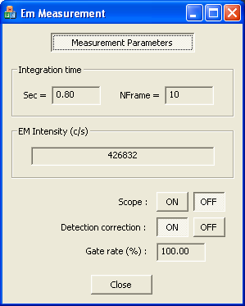 | 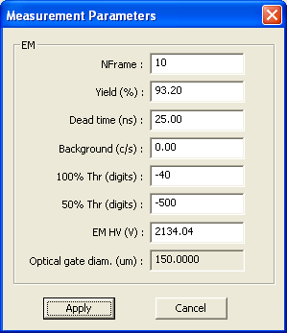

The EM Measurement Box
- Measurement parameters : clicking this button opens the editing box Measurement Parameters. The box is opened with the parameter values as they are in the setup file.
- Integration time. Is displayed both in second (Sec=) or in number of 80 ms frames (Ntrame=) . Both are dependent, according to the relationship
sec = Nframe * 80 ms
The EM counts are counted over the Nframe frames and displayed in the EM Intensity field. Nframe is edited in the Measurement parameter box.
- EM Intensity (c/s) displays the EM count rate, averaged over Nframe frames.
- Scope ON/OFF, switching button for opening and closing the Oscilloscope box.
- Detection correction (ON/OFF), switching button for enabling/disabling the EM correction (defined by the Yield Y_{EM}, the dead time τ and the Background rate Bkg defined in the Measurement parameters box) according to the formula
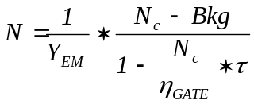
η_{GATE} is defined in the ion optics user's guide § Dead time corrections dependance on the gating (Setup #514)
The same selection is valid for the analyses (exept for image analysis) but not for Mass Calibration and Tuning.

Contents ↑

The EM measurement parameters box
- Nframe edits the number of 80 ms frames which define the acquisition integration time - (Setup #44)
- Yield(%) edits the Yield Y_{EM} used in the EM correction formula. (Setup #34)
- Deadtime (ns) edits the deadtime τ used in the EM correction formula. (Setup #258)
- Background (c/s) edits the background rate Bkg. (Setup #33)
- 100% Threshold (mV) edits the current EM threshold value used in the EM HV Test (See below the section § The EM HV Test). (Setup #261)
- 50% Threshold (mV) edits the EM threshold used in the EM HV Test (See below the section § The EM HV Test). (Setup #264)
- EM HV (V) edits the EM High Voltage which can be also set by hand in the Tuning synoptics or automatically set by the The EM HV Test. (Setup #37)
- Apply writes in the Setup file the Measurement Parameters box modified parameters and closes the box
- Cancel closes the box without writing in the setup file the box modified values.
Contents ↑

Links with the Setup file

# | Set-up Label | Comments
33 | EM Background | (EM Measurement tool, analyses)
37 | EM HV | EM High Voltage
34 | EM Detection efficiency | EM Yield (EM Measurement tool, analyses)
44 | Integration time for the Secondary current | (EM Measurement tool)
258 | EM_DEAD_TIME_VAL | EM dead time (EM Measurement tool, analyses)
261 | EM_THR_100_VAL | See EM HV Test. Expected to be the current EM Threshold (Setup #36)
264 | EM_THR_50_VAL | See EM HV Test
501 | Optical gate flag | (0/1) (EM & FCs Measurement tool, Analyses)
513 | E-Gate norm. flag | (0/1) (EM & FCs Measurement tool, EM PHA tool)
514 | EM corr. flag | (0/1) (EM Measurement tool, EM PHA tool, Analyses)
515 | BBS flag | (0/1) must be always to 0 except in EM & FCs Measurement tool.

Contents ↑

The EM Yield test

Overview
The EM Yield target is to launch a test routine purposed for measuring automatically the EM Yield and for writing the result in the setup file. See the EM physical model and the meaning of the EM Yield in the ion optics user's guide § Electron multiplier (EM) .
It is recommended to run previously the EM HV routine.
The routine achieves a procedure consisting in measuring the same signal successively with the FCs Faraday channel and with the EM channel. As the FCs measurement is supposed to be 100% of the signal, it is therefore straight to deduce the EM yield as the ratio EM/FC.

The EM Yield Sketch (one cycle time diagram)

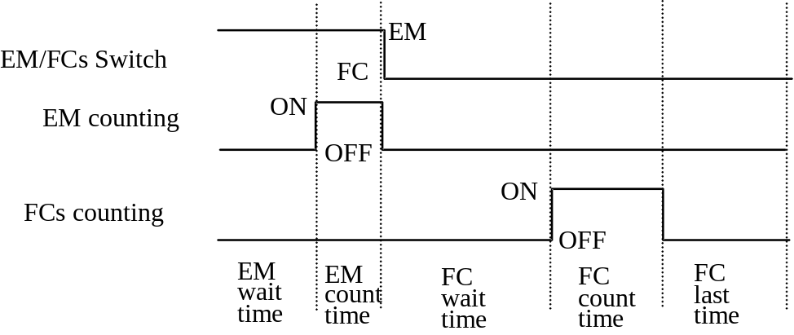

Description

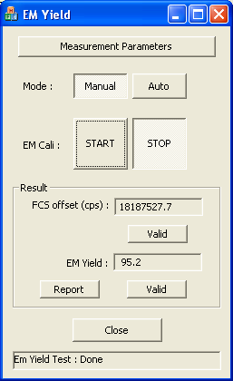 | 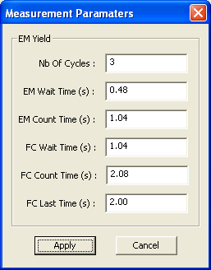

Contents ↑

The EM Yield main box
- Measurement parameters : clicking this button opens the editing box Measurement Parameters. The box is opened with the parameter values as they are in the setup file.
- Mode (Auto/Manual) With Auto the routine will be launched with START, and the result will be automatically wrote in the setup file. With Manual, the routine will be also launched with START, but the operator will be asked to validate the result for writing it in the setup file.
- START/STOP Starts and stops the EM Yield routine. The routine is performed with the setup parameters which can be edited in the measurement box.
- FCS offset Valid The routine measures also automatically the FCs offset. Valid validates the offset measured value.
- EM Yield displays the EM yield as it is in the setup file or as it results from the EM Yield routine. Note that the EM yield can be edited in the EM Measurement parameter box. (Setup #34)
- Valid, button to be pressed in the Manual mode for writing the EM Yield routine result in the setup file.
- Report transfers the test results in a word document.
- Close

The EM Yield parameter box
- Nb of cycles edits the number of EM/FC cycles which will be repeated within the EM Yield routine. (Setup #270)
- EM wait time (s) edits the waiting time displayed in the EM Yield sketch. (typ. 0.5 sec) (Setup #273)
- EM count time (s) edits the counting time displayed in the EM Yield sketch. (typ.1sec) (Setup #276)
- FC wait time (s) edits the waiting time displayed in the EM Yield sketch. (typ. 1 sec) (Setup #279)
- FC count time (s) edits the counting time displayed in the EM Yield sketch. (typ. 0.5 sec) (Setup #282)
- FC last time (s) edits the last time displayed in the EM Yield sketch. (typ. 0.5 sec) (Setup #285)
- Apply writes in the Setup file the Measurement Parameters box modified parameters and closes the box
- Cancel closes the box without writing in the setup file the box modified values.
Contents ↑

Links with the Setup file
# | Set-up Label | Comments
34 | EM Detection efficiency | EM Yield (EM Measurement tool, depth profile)
270 | EM_YIELD_NB_CYCLE_VAL | Number of EM/FC cycles repeated in the EM Yield tool.
273 | EM_YIELD_WAIT_TIME_VAL | EM Yield tool timing parameter
276 | EM_YIELD_COUNT_TIME_VAL | EM Yield tool timing parameter
279 | EM_YIELD_FC_WAIT_TIME_VAL | EM Yield tool timing parameter
282 | EM_YIELD_FC_COUNT_TIME_VAL | EM Yield tool timing parameter
285 | EM_YIELD_LAST_TIME_VAL | EM Yield tool timing parameter

Contents ↑

The EM PHA

Overview
The EM PHA tool is purposed to display the EM PHA distribution curve. PHA states as "Pulse Height Amplitude". The PHA curve allows the operator to check the Electron Multiplier (EM) aging, and to decide a possible EM HV increase. The involved physical principles are presented in the ion optics user's guide § Electron multiplier (EM) . As it is explained in this last user's guide, it is recommended to keep the EM Threshold constant and to play only with the EM HV for keeping the same PHA curve template all along the EM lifetime. EM HV automatic tuning is made possible with the EM HV routine (see below).

The EM PHA routine is basically a scan-acquisition, where EM Threshold is the scanned parameter and the EM counts the acquired signal.

Description

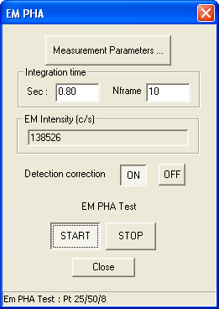 | 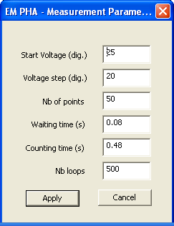

The EM PHA main box
- Measurement parameters : clicking this button opens the editing box Measurement Parameters. The box is opened with the parameter values as they are in the setup file.
- Integration time displays the time or the number of frames corresponding to the acquisition before starting a PHA curve acquisition. This parameter is edited in the EM Measurement/Measurement parameters box (Setup #44).
- EM intensity (c/s) displays the EM signal before starting a PHA curve acquisition.
- detection correction (ON/OFF) switching button for enabling/disabling the EM correction. See above the section § EM Measurement tool. It is recommended to set it to OFF for the PHA curve acquisition. (Setup #514)
- E-gate normalization (ON/OFF) normalizes the displayed EM intensity to the 100% gate i.e. divides the intensity by the gate rate η_{GATE} . See above the section § EM Measurement tool. It is recommended to set it to OFF for the PHA curve acquisition (Setup #513)
- START/STOP Starts or stops the PHA curve acquisition. START opens the PHA curve box containing agraphical window. See below the section § The EM PHA curve box.
- close returns to the main Tool pad while closing the PHA box.

The EM PHA Measurement Parameters Box
- Start Voltage (mV) edits the initial EM Threshold of the PHA scan-aquisition routine. (Setup #288)
- Step Voltage (mV) edits the EM Threshold step of the PHA scan-aquisition routine. (Setup #291)
- Nb of points edits the number of points of the PHA scan-aquisition routine. (Setup #294)
- Waiting time (s) edits the time between 2 points of the PHA scan-aquisition routine. (Setup #297)
- Count time (s) edits the EM counting time for each point of the PHA scan-aquisition routine. (Setup #300)
- Apply closes the EM PHA Parameters box and writes the edited parameters in the setup file.
- Cancel closes the EM PHA Parameters box without writing the edited parameters in the setup file.

Contents ↑

The EM PHA Curve Box

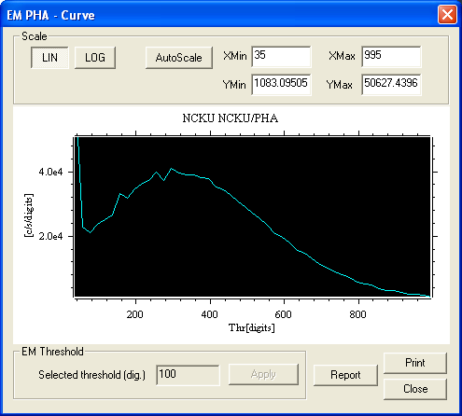 | For the Scale selections and editing field, see above the section § The Oscilloscope box.  EM Threshold can be set by clicking the graphical window at the required position. A cursor is then displayed (Setup #36)  Apply writes the EM Threshold edited value in the setup file.  Report transfers the PHA curve in an ASCII file

Links with the Setup file
# | Set-up Label | Comments
36 | EM Threshold | ( EM PHA tool, Tuning)
288 | EM_PHA_START_VOLTAGE_VAL | ( EM PHA tool)
291 | EM_PHA_STEP_VOLTAGE_VAL | ( EM PHA tool)
294 | EM_PHA_NB_POINTS_VAL | ( EM PHA tool)
297 | EM_PHA_WAIT_TIME_VAL | ( EM PHA tool)
300 | EM_PHA_COUNT_TIME_VAL | (EM PHA tool)
513 | E-Gate norm. flag | (0/1) (EM Measurement tool, EM PHA tool)
514 | EM corr. flag | (0/1) (EM Measurement tool, EM PHA tool)

Contents ↑

The EM HV routine

Overview
As it is explained in the ion optics user's guide § Electron multiplier (EM), when an EM is used, there is an aging phenomenom consisting in a gain decrease and requiring therefore to increase the EM High Volgage (EM HV) all along the EM life, for compensating the aging.
The EM HV routine is purposed to re-adjust automatically EM HV. EM HV is set to keep the PHA curve within a given template featured by a couple of value (Thresh(100%), Thresh(50%)). Practically, the routine does not process the PHA curve, but it just set EM HV so that when setting the EM discriminator threshold to Thresh(50%), the signal is the half of this corresponding to Thresh(100%). Note that the Thresh(100%) value is typically the same that the working threshold, normally kept fixed all along the EM life

Description

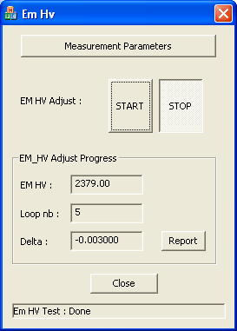 | 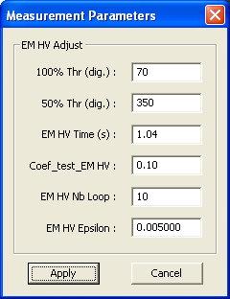

The EM HV Adjust routine main box
- Measurement parameters : clicking this button opens the editing box Measurement Parameters. The box is opened with the parameter values as they are in the setup file.
- EM HV adjust (START/STOP) Starts or stops the test
- EM_HV displays the EM HV value all along the routine completion. (Setup # 37)
- Loop nb displays the number of the routine loop in progress.
- Delta displays δ which must be smaller and smaller if the routine is converging (See below the definition of δ)
- Close closes the box

The EM HV Adjust routine parameter box
- 100% Thr (digits) edits Threshold(100%), the reference threshold value normally close to the working threshold value. (typ 70) (Setup # 261)
- 50% Thr (digits) edits Threshold(50%), which set the EM signal at the half of the amplitude obtained when the threshold is set at Threshold (100%). (typ 350) (Setup # 264)
- EM HV Time (s) edits the step counting time, corresponding to Threshold(100%) or Threshold(50%) as well (typ. 1 s.) (Setup # 303)
- Coeff_test_EMHV edits the routine feedback coefficient k. At each routine step, EM HV is readjusted accordingly to
EMHV_{NEW} = EMHV_{OLD} * k *δ
with 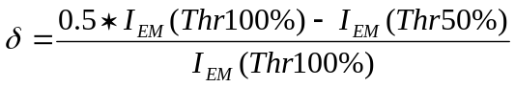
I_{EM}(Thr100%) and I_{EM}(Thr50%) being the EM signal obtained with the EM threshold set at Thr100% and Thr50%.
(typ 0.1) (Setup # 306)
- EMHV_nbloop edits the routine maximum number of loop. (typ. 10) (Setup # 309)
- EMHV Epsilon edits the routine convergence test coefficient which is compared to δ (typ 0.005) (Setup # 312)
- Apply writes in the Setup file the Measurement Parameters box modified parameters and closes the box
- Cancel closes the box without writing in the setup file the box modified values.

EM HV links with the Setup file

# | Set-up Label | Comments
37 | EM HV | ( EM Measurement tool, EM HV tool, Tuning)
261 | EM_THR_100_VAL | ( EM HV tool)
264 | EM_THR_50_VAL | ( EM HV tool)
303 | EM_HV_COUNT_TIME_VAL | ( EM HV tool)
306 | EM_HV_COEF_TEST_VAL | ( EM HV tool)
309 | EM_HV_NB_LOOP_VAL | ( EM HV tool)
312 | EM_HV_EPSILON_VAL | ( EM HV tool)

Contents ↑

Diagnosis
The Diagnostic tool allows to display simultaneously all the main devices voltage mesurements. The purpose is to help the expert operator when a failure occurs, i.e. no primary or no secondary signal is detected, to check the working of these main devices. (See the panel, below) | 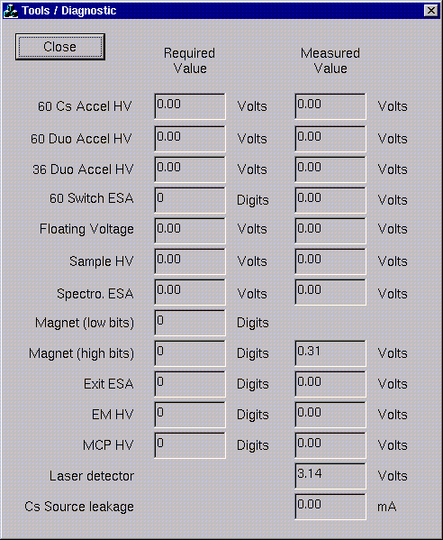

Spot Shape
Select Spotshape un the Tools bar

Overview
The basic principle of this spot size measurement is to determine the apparent width of a sharp interface (assumed to be sharper than the spot size) from line scans performed on scanning ion images recorded with the primary spot to be characterized. The primary spot size is defined as being equal to this apparent width.
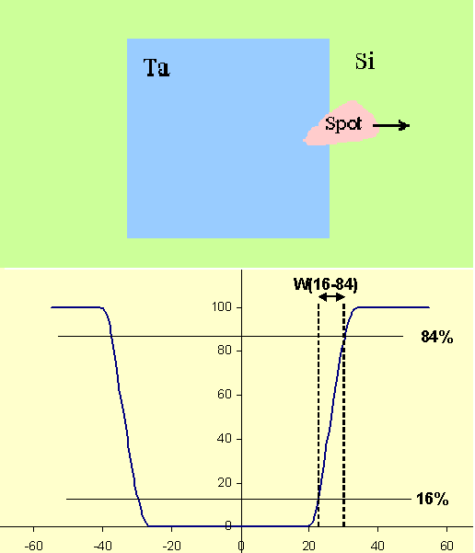 | The opposite figure illustrates this principle:  A primary beam, (asymmetric in the figure) is rastered over a patterned Ta pad deposited onto a Si substrate.  The bottom plot displays the variation of the Si secondary signal.  Ideally, the signal is at a given level, calibrated at 100 on the silicon and falls down to zero when entierely located on the Ta pad.  It is then possible to measure on any edge the width between 2 given levels. Fof example, 16% and 84% as in the figure.  Ideally, both edges gives the same result.

In practise , while the secondary signal is exactly zero when the spot is located onto the To area, providing the sample area was slighly cleaned (by a simple pre-sputtering), the signal level is not constant onto the Si area since the emission yield may depend strongly on the primary ion implantation conditions, i.e. the history of both the contamination and the pre-sputtering. In the hereunder figure, the signal curve is not flat

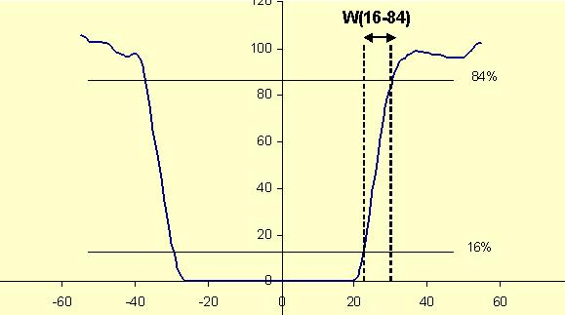

It is therefors no more possible to determine without any ambiguity what is the reference 100%. This uncertainty may be negligible for the measurement of a width at 16%-84%, but it is never negligible if a better accuracy is required, as it is shown in the hereunder figure in the 1%-99% case.
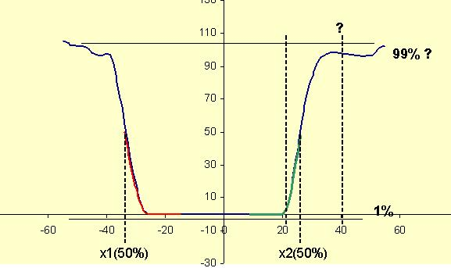

In fact, on the right hand side edge, the fisrt part of the curve (0% to 50%, green line) can be easily interpreted as containing the information about the right hand side of the spot while the second part of the edge, which would be expected to contain the information is more questionnable.. The solution to this issue consists of replacing the second part of the right hand side edge curve by the second part of the left hand side edge curve (0-50%, red line) which contains the same information.

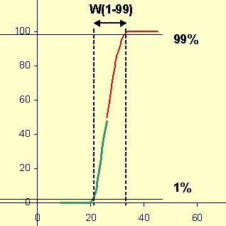 | This final curve has been obtained by stitching to the green part curve curve, the red curve, after a transformation  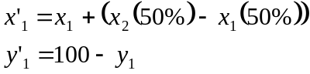  Were the index 1 corresponds to the left hand side edge pulse while the index 2 is related to the right hand side edge.  Note that even if the 100% level is determined with a large uncertainty, The uncertainty of x(50%) will be quite reduced.

The spotshape tool offers two modes, the single mode and the double mode.
- The single mode requires a single scanned ion image which must contain at least a vertical edge and a horizontal edge.
- The double mode requires 2 scanned ion image, each image expected to contain a vertical edge and a horizontal edge, typically a corner, the direction of the second image corner being opposite with respect to the first image corner.

Procedure to measure a beam size with the single mode
First of all, the operator records one ion images in the scanning mode using the standard image acquisition program. This image must have at least one vertical edge and one horizontal edge. Note that the computation of the beam size is based upon the raster size recorded with the scanning ion image. The Rsster size is therefore required to be correctly calibrated .

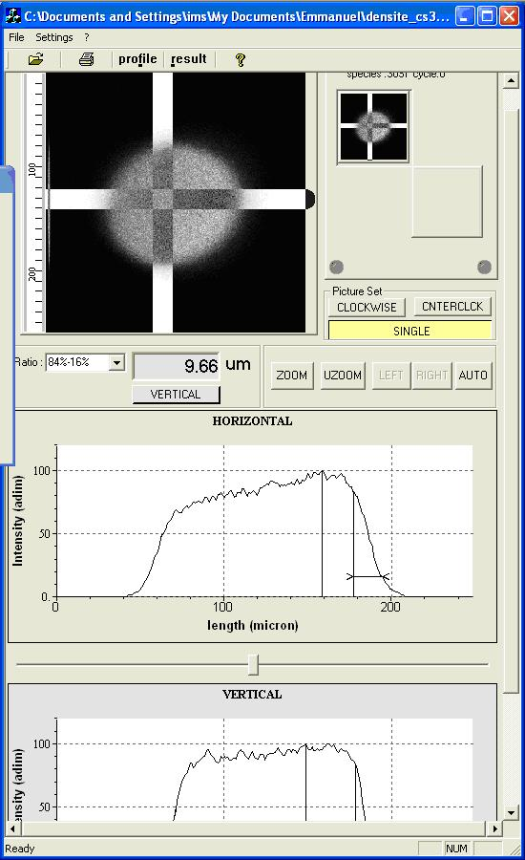  Maximum position, defines the 100% level  84%  16% | The program scans a rectangle the dimensions of which are defined in "Settings" both along the X and Y axis.  The positions of the scanning axis can be ajusted with the mouse  The curve are plotted in the window and the results are displayed either in the main screen or in the box which is opened when clicking "Results"  As it can be shown oin the opposite figure, the recorded pattern may also be a circular disc. For large spots, it is actually convenient to scan the beam over a blank area and to use the Field Aperture, providing that it is checked that the immersion lens aberrations are smaller than the spot width which is to be measured.

Procedure to measure a beam size with the double mode
First of all, the operator records two ion images in the scanning mode using the standard image acquisition program. Typically, the sample is the CAMECA test sample (Ta/Si grids) and the imaged area is a pattern with a squared shape of 400 µm side. This squared pattern can assumed to be divided in four sectors NW, NE, SW, SE has shown in the hereunder figure.
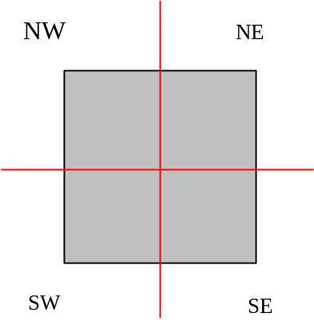
The two images must be recorded for two opposite corners : NW-SE or NE-SW. The primary raster size is adjusted as a function of the primary beam size to be measured. For accurate measurement, the "size" of one pixel (= raster_size/256) must be ≤ spot size. The image field of view is centered on the corner of the Ta(or Au) pattern and the Si species is imaged.
Once these two images have been acquired, the operator must run the Spot Shape program. The main panel Spot shape and position opens.
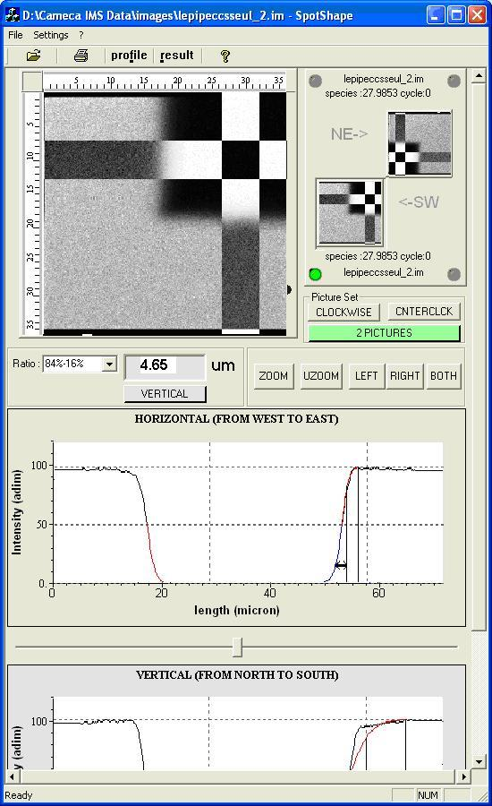

A pair of images must be entered by using File/open
This pair must correspond either to a couple of corners (NW/SE) or a couple (SW/NE)
ROTATE is purposed to select either (NW/SE) or (SW/NE)
Then
- press one of the available corner (e.g. NE), and open the corresponding file
- press the otherone of the available corner (e.g. SW), and open the corresponding file

The main image window allows to set by mouse where the X or Y scan must be done
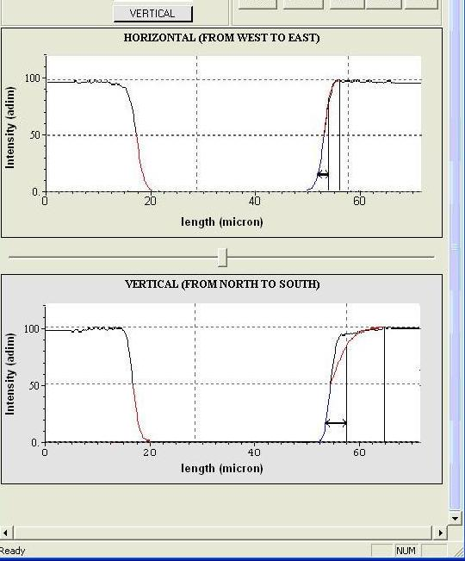

Contents ↑

the result box
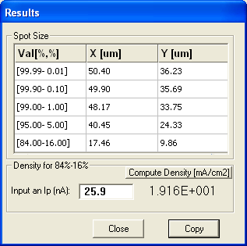 | Press results for displaying the results  The compute density program takes into account the primary current Ip, recorded with the scanning ion image and an elliptic spot the dimensions of which are respectively the 16%-84% X and Y measured width.  Clicking the button Copy will load the displayed results into the computer clipboard. The Past function of a window application (for example, Word) will download these data in the document.

Other boxes
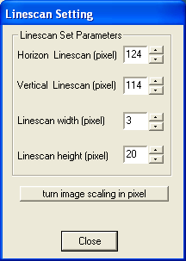  First two lines corresponds to the scanning axis position, movable with the mouse.  Linescan width and height set the dimensions of the rectangle which is scanned along the image for giving the plots.  The overall image is consisting of 256x256 pixels | 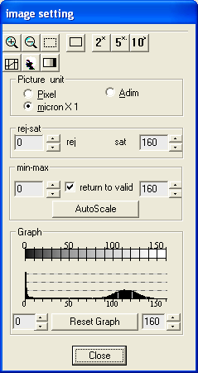

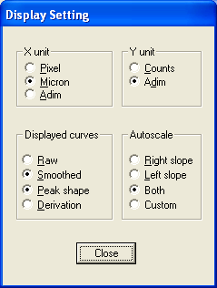 | 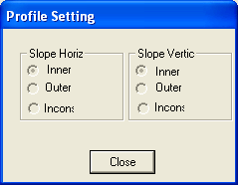

Spot Shape links with the Setup file

# | Set-up Label | Comments
483 | DFC_CORNER_ID_VAL | (Spot Shape Tool)
486 | DFC_LINESCAN_X_VAL | (Spot Shape Tool)
489 | DFC_LINESCAN_Y_VAL | (Spot Shape Tool)
492 | DFC_LINESCAN_W_VAL | (Spot Shape Tool)
495 | DFC_LINESCAN_H_VAL | (Spot Shape Tool)

Contents ↑

Analysis Filter

Overview
The filter is a routine which can be activated either in real time, whenever a depth profile is run, or off-line in this filter tool. In this last case, all the input data can be edited, while in the analysis case, they are read from the setup file or deduced from the analysis definition parameters.
This tool is targetted to the browsing of both the raw data depth profile analysis file and the filtered data file. It must be known that along a depth profile analysis, a measurement is performed at every frame for all the measured channels. A 0.08 second frame consists of a complete 1024 rastered line sequence. The different measured channels are
- The FCp Faraday primary current.
- The FCs Faraday secondary current.
- The EM secondary current.
- The Laser Interferometer crater depth.

These elementary frame measurements are further integrated within an analysis process according to the Filter parameters defined in the Analysis Definition panel. (refer to the Analyses software user's guide.) The analysis so-called Filter achieves also some detector corrections.
A depth profile analysis generates the frame per frame raw data in the filtert.txt file and the filtered data in both binary analysisname.dp and ASCII analysisname.dp_asc files. It is possible to generate a filtered data file from the Filter tool by using save as. It contains the same data as analysisname.dp_asc but contrary to analysisname.dp_asc it does not contains some analysis conditions.

The purpose of this Filter Tool is

- To check that the data transformation operated by the Filter is correct.
- To check that the analysis waiting time, as it is normally computed, depending on the set-up parameters is consistent with the actual magnet settling time.
- To modify the output file with new filter parameters (detector correction...)
- It may also be used for modifying some set-up parameters.

Opening the tool and saving the output file

For opening the Filter Tool, click in the main Tool panel and select the file in the hereunder box:

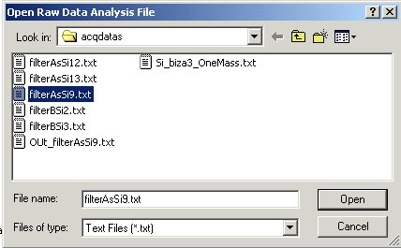

For saving a new output file, corresponding to new filter selection, click file/save as and use the hereunder box

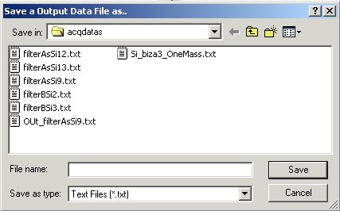

Description

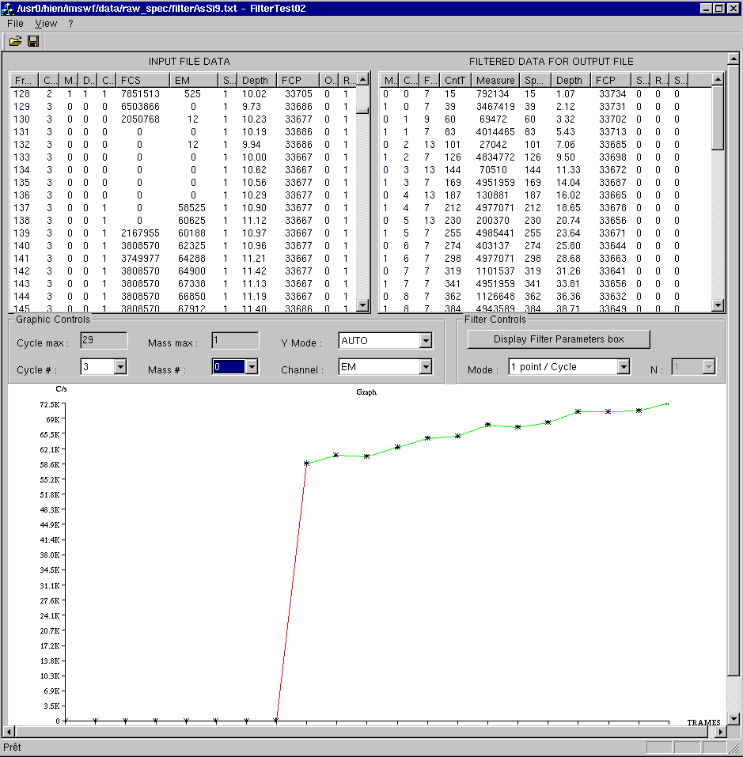

Selecting a cycle and a mass will display both the frame text corresponding to these cycle and mass, and the plot channel vs frame corresponding to the selected channel.

Raw data file browser.

- Cycle max : Display Field . File total number of cycles.
- Cycle # : Editing Field . Selected cycle number (must ne in [0, Cycle Max])
- Mass Max: Display Field . File total number of Masses.
- Mass #: Editing Field . Selected mass number (must ne in [0, Mass Max])
- Y Mode (AUTO/Ymin=0.0)
- Channel selection (FCP/EM/FCS/Depth)

Filtered data browser.

- Display filter parameters opens the filter parameters editing box
- Mode (1 point/Nframe or 1 point/cycle)
- N for the above case 1 point/Nframe

The input file content
The input file contains one line per frame. Each line consists of the following data
- Frame is the Frame number
- Cycle is the Cycle number
- Mass is the Mass number
- Det is the switched secondary detector (0=EM, 1=FCs, 2=security). It is actually the status of the FCs/EM deflector which adresses the beam towards the EM or the FCs Faraday cup.
- Cnt is the countin status ( 0=waiting time, and 1=counting time)
- FCS is the FCs signal (cps)
- EM is the EM signal (cps)
- S is the Sputtering flag (0=No sputtering, 1=Sputtering). This corresponds to the analysis Beam Blanking option, where the primary beam is off during the waiting time.
- FCP is the FCp signal (pA)
- Offset is the Sample HV offset (Volts)
- Range is the FCp electrometer range

The outut file content
The input file contains one line per cycle and per mass. Each line consists of the following data
- Mass is the Mass number
- Cycle is the Cycle number
- Frame is the line first frame Frame number
- AnalT is the overall analysis time.
- Measurement is the selected channel signal (cps). Refer below to the section § Computing the output measurement.
- Sputtering time is the actually sputtered time. Refer below to the section § Computing the output Sputtering time.
- FCP is the FCp signal (pA)

Filter parameters
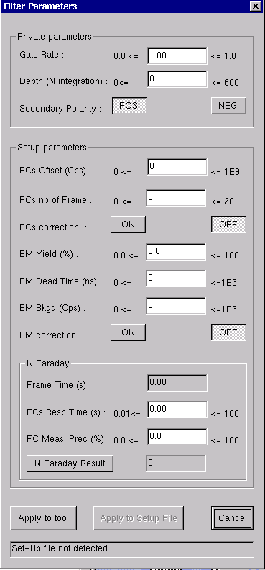 | Private parameters  All the private parameters are editable in this block. In the real time filter, these parameters are calculated from analysis parameters.  Gate Rate is normally the ratio (Measured pixels/ Overall frame pixels). Automatically computed when the filter is acivated within an analysis. The EM deadtime correction is gate rate depending.  Secondary polarity is normally the analysis instrument secondary polarity. It determines which FCs offsets must be read in the Set-up in the next block.  Set-up parameters  All these parameters default (except FCs correction ON/OFF and EM correction ON/OFF) are read from the setup file. They can also be written in the setup by clicking Apply to Setup file.  FCs Offset (cps), editing field, per default, the offset contained in the setup #387 if sec pol=pos or setup #607 if sec pol=neg.  EM Yield (%), editing field, Y_{EM} per default, the content of setup #34  EM Bkgd (cps) , editing field, per default, the content of setup #34  EM correction (ON/OFF) If ON, the correction of formula () is applied  Frame Time (s) displays the Tfr frame time stored in the setup #540  FCS Resp Time (%), editing field, is the Tfcs Faraday channel time constant (Setup#541)

FC Meas Prec (%), editing field, is the prec precision required for an analysis (Setup#535)

N Faraday result, if the button is presed, displays the calculated NFaraday number of frames. The first NFaraday frames within a counting time must not taken into account in the output computation.

Apply to Tool closes the box and applies the box parameters to the filter.

Apply to Setup File writes the Setup parameters into the setup file.

Cancel closes the box without changing anything.
Contents ↑

The filter process

Overview
The input file contains all the frame data acquired along an analysis. There one data line per frame. The filter operates over the input file a data reduction which generates output data points mainly featured by 4 coordinates (Mass, Sputtering time, Depth, Measurement, FCp)
Where Measurement stands for secondary ion signal and FCp for primary Faraday signal.
The filter data reduction is described in the next below sections:
Computing the output "Measurement"
Computing the output "Sputtering time"
Computing the output "FCp"
Other output data

Computing the output "Measurement"

Overview
The secondary ion signal is expressed in the output file Measurement column by a single number per cycle and per mass. This Measurement results from the all the input file EM and FCs data corresponding
- When det=0 for all the mass-cycle lines of the input file, only the EM channel data are considered and they are processed according to the EM case (See below)
- When det=1 for all the masses of the input file, only the FCs channel data are considered and they are processed according to the FCs case (See below)
- When there are both some det=0 frames and other det=1 frames within the same mass cycle, this implies that a software or hardware security switching has occured duning the mass cycle. The data are then processed according to the Mixed EM and FCs case. (See below).

The next 3 sections are valid for the 1 point per cycle Mode. With this mode, there is always a single line per mass and cycle in the output file.
With the 1point per N frames Mode, there may be several points par mass and cycle. Refer to the section § The "1 point per N frames" Mode.
Contents ↑

The EM case (1 point per cycle)

The filter computes the average of the EM channel counting time frames

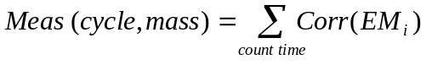
Where
i is the frame index
Count time means the set of the given the mass cycle counting time frames (Cnt_{i}=1)
Corr(EM_{i}) is the correction function applied to the EM channel i frame.

The EM correction is applied to the measured EM_{i} count rate according to :
if (Setup#514=1), 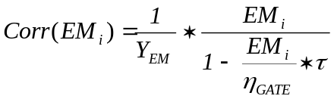
if (Setup#514=0), 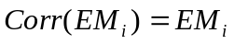
Where

- Y_{EM} is the EM yield. There is a dedicated routine (refer to the section § The EM Yield Test) for measuring it and writing it in the Setup file (#34)
- η_{GATE} is the gate ratio. η_{GATE} is defined as is the area ratio gate/frame (For the precise definition, Refer to the secondary ion optics user's guide). When the filter is activated in real time by the depth profile analysis η_{GATE} is computed according the data entered in the OIP panel. When the filter is run from this tool, it must be entered in the field gate rate.
- τ is the EM dead time (Setup # 258). Normally, the EM preamplifier is configured to give a deadtime of 25 ns.
- EM_{i} is the i frame EM channel count rate

Refer to the secondary ion optics user's guide/Electron Multiplier for a physical presentation of EM detector.
Contents ↑

The FCs Case (1 point per cycle)
The filter computes the average of the FCs channel counting time frames, after having rejected the first N_{faraday} frames

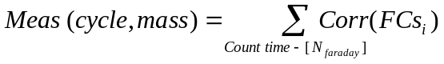

Where
- Count time –[N_{faraday}] means the set of the given the mass cycle counting time frames (Cnt_{i}=1), without the first N_{faraday} frames. (See below for the definition of N_{faraday})
- Corr(FCs_{i}) is the correction function applied to the FCs channel i frame.

N_{faraday} is defined as

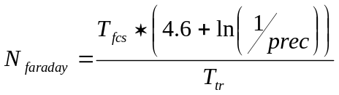
Where
- precision (%) (setup # 535) is the required precision for the FCs measurement (typ 1%). It determines the number of frames Nfaraday necessary for the FCs settling time.
(Example: if prec=1% and T_{fcs}=0.1 sec, N_{faraday}=4.6 (rounded to 5) )
- FCs response time T_{fcs} (setup # 541) is the FCs channel response time taken into account in the FCs post-waiting time.
- frame time T_{fr} (setup # 540) is the frame time (0.08 sec for the IMS 7f ) .

The FCs correction is applied to the measured FCs_{i} count rate according to:

if (Setup#517=1), 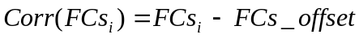
if (Setup#517=0), 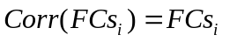
Where

- FCs_offset (cps) (Setup#387, #607) is the FCs signal offset, stored in the setup file, depending the secondary polarity (#383 pos and #607neg). Refer above the section § FCs offset routine for setting these values.

Refer to the secondary ion optics user's guide/FCs for a physical presentation of Faraday detector.
Contents ↑

The mixed EM and FCs case (1 point per cycle)
It may occur that a mass cycle counting time consists of both EM and FCs frames (ie frames with det=0 and det=1). This occurs when the detection of the secondary ion signal level produces an automatic switch. Refer to the secondary ion optics user's guide/Switching FCs/EM . In this case, there are also some frames with det=2, corresponding to the switching detection, and these frames are systematically rejected.

For computing the mass cycle Measurement count rates, the following frames are averaged:
- All the EM (det=0) frames
- The FCs frames (det=1), except the N_{rejected} frames after the switching to det=1, where N_{rejected}=sup(N_{faraday}, N_{secu}) , N_{secu} being a minimum number of frames located at Setup #608 . Typical value of N_{secu}=6.

The "1 point per N frames" Mode
The 1 point per N frames Mode is purposed for allowing to define an analysis with very a few number of cycles and consequently very long counting times, while keeping a time resolution of a few frames. That avoids to switch the magnet if it is not necessary, for exemple, when a single mass is actually required to be monitored while another mass (typically, the matrix mass).

In this case N_{frames} must be edited in the main panel, and there will be several lines per mass and cycle in the output frames.

- For the EM case, the frames are averaged per block of N_{frames} frames, instead of one counting time.
- For the FCs case, the frames are also averaged per block of N_{frames} frames, but the first N_{faraday} frames after the counting time are rejected.
- For the mixed case, N_{rejected} frames are rejected after a switching EM to FCs, where N_{rejected}=sup(N_{faraday}, N_{secu}), as with the 1point per cycle mode.
Contents ↑

Computing the output "Sputtering time"
For every i frame, a corresponding sputtering time can be easily calculated with the formula:
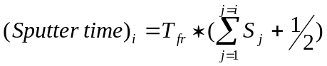
Where
- T_{fr} is the frame time
- S_{i} is the input file frame boolean which indicates if the i frame corresponds to Beam On.

The output sputtering time is the average of all the input sputtered times computed over all the frames taken into account in the output point Measurement computation.

Contents ↑

Computing the output "FCp"
The output FCp calculation depends on the Sputtering during waiting time/ Non Sputtering during waiting time mode selected for the considered analysis.

Sputtering during waiting time mode
This is the more used mode. The primary beam is then continuously sputtering the sample, even during the waiting time. In the input file, all the frame sputter flags S are set to 1. As it is explained above in the section § Fcp Measurement, the primary current is sampled for measurement at every frame. The output FCp is then simply the average of input FCp, computed over all the frames taken into account in the Measurement computation.

Non Sputtering during waiting time mode (Beam-Blanking mode)
In this mode, the primary current blanked towards the primary Faraday cup at every waiting time. In the input file, all the waiting time sputter flags S are therefore set to 0, while the counting time S flags are set to 1. The primary beam is then no more continuously sampled since at evevy waiting time, the beam-blanking which brings the overall primary current into the Faraday cup leads to a primary reading range switching, and the reverse range switch occurs therefore when the beam is ON again and sampled again. Practically, most of the cycle consists of transient phenomenas: Not settled signal, overshoots, oscillations.
For computing the output FCp, the filter averages all the waiting time input FCp, except the first six.

Other output data

- As all the frames averaged for giving an out point are of the same Mass and Cycle, the output mass and cycle are those of the input frames.
- AnalT, the overall analysis time is the sum of all the frame times upto the frame selected for determining the sputtering time

Contents ↑

Setup file parameters
N° | Format | Comment | Comment-2 | Edit
33 | double | EM Background | (EM Measurement tool, analyses) | Tools
34 | double | EM Detection efficiency | EM Yield (EM Measurement tool, analyses)  Max & Min # 253 & 254 | Tools
56 | string | User raw data directory | (Depth Profile, Mass spectrum ? Analysis)
414 | double | THR_SECU_SOFT_VAL | (Multichannel tool, Analysss, Mass calib) EM-FC threshold | Tools
417 | double | HYST_SECU_SOFT_VAL | (Multichannel tool, Analysss, Mass calib) (%) hysteresis effect to EM-FC switch | Tools
258 | double | EM_DEAD_TIME_VAL | EM dead time (EM Measurement tool, analyses) | Tools
387 | double | FCs Offset (pos. polarity) value | (FCs Measurement tool, FCs Test tool, Tuning, Analyses) | Tools
496 | Bool | Primary Faraday Cup offset correction | (FCp Measurement tool) | Tools
517 | Bool | FCS corr. flag | (FCs Measurement tool, Tuning, Analyses) | Tool
535 | double | prec | precision (%) parameter (Depth Profile Analysis)
540 | double | Tfr | frame time (s)  (Depth Profile Analysis)
541 | double | Tfcs | FCs response time (s)  (Depth Profile Analysis)
542 | double | Tfcp | Tfcp response time (s)  (Depth Profile Analysis)
596 | double | Coef conversion depth tics to µm | red wave length (Crater depth tool, Analysis)
607 | double | FCs Offset (neg polarity) value | (FCs Measurement tool, Tuning, Analyses) | Tool
608 | double | fc_em security frame number | within a FC counting time, the signal/threshold is tested after this number of frames.  (Depth Profile Analysis)

Contents ↑

The additional analysis parameters: magnet settling time, FC/EM threshold
The magnet settling time parameters
There is no tool especially dedicated for the magnet (Refer to the secondary ion optics user's guide), but it may be useful to know the adress of the four parameters used for calculating the magnet swiching time. The waiting time is computed according to the formula:

If ΔM>0

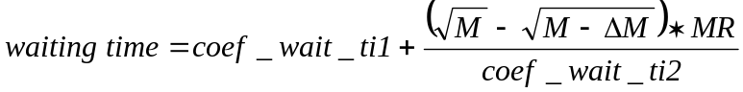
If ΔM<0

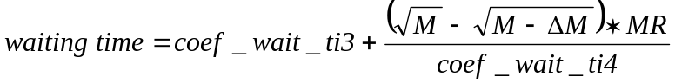

Where coef_wait_ti1 (Setup # 545), coef_wait_ti2 (Setup # 546), coef_wait_ti3 (Setup # 547), coef_wait_ti4 (Setup # 548) are Setup parameters and MR is the spectrometer Mass Resolution.
Typical values
 | IMS 7f
coef_wait_ti1 (s) | 0.5
coef_wait_ti2 (s) | 7000
coef_wait_ti3 (s) | 0.4
coef_wait_ti4 (s) | 10000

The FC/EM Threshold parameters
Along an analysis, the automatic FC/EM and EM/FC switching involve 2 parameters, soft security threshold (Setup #414) and the hysteresis security threshold (Setup #417) . For the definition of these coefficients, refer to the secondary ion optics user's guide.

N° | Format | Comment | Comment-2 | Edit
543 | double | Mass dispersion coef | Spectrometer mass dispersion coefficient. (Tuning, Analyses)
545 | double | STP_LBL_COEF_WAITTI_1 | Magnet waiting time calculation (Depth Profile Analysis)
546 | double | STP_LBL_COEF_WAITTI_2 | Magnet waiting time calculation (Depth Profile Analysis)
547 | double | STP_LBL_COEF_WAITTI_3 | Magnet waiting time calculation (Depth Profile Analysis)
548 | double | STP_LBL_COEF_WAITTI_4 | Magnet waiting time calculation (Depth Profile Analysis)
414 | double | THR_SECU_SOFT_VAL | (Multichannel tool, Analysis, Mass calib) EM-FC threshold | Tools
417 | double | HYST_SECU_SOFT_VAL | (Multichannel tool, Analysss, Mass calib) (%) hysteresis effect to EM-FC switch | Tools

The set-up browser

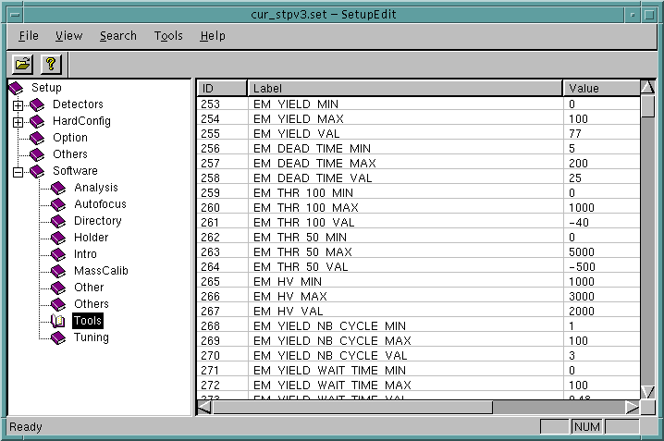

The setup file contains all the set of instrument configuration parameters. For each parameter, the file contains a number , a comment which can be only the parameter label, and the parameter value. Note that the parameters are generally grouped per 3: The current value, the maximum value allowed by the software and the minimum value allowed by the software.

The Set-up browser allows the operator
- To display and to edit any setup parameter (Click onto the line for editing a parameter).
- To view the parameter tree.
- To search for a parameter from its number or its label (Menu: Search)

For the detailed setup list, see the Set-up Reference List

Contents ↑

